B.M.S COLLEGE OF ENGINEERING BENGALURU
Autonomous Institute, Affiliated to VTU



SPC AAT Report on

BANK ACCOUNT SIMULATOR

Submitted in partial fulfillment of the requirements for AAT

Bachelor of Engineering
in
Artificial Intelligence and Machine Learning

Submitted by:

AMIT HIPPARAGI

ADITYA

Department of Artificial Intelligence and Machine Learning
B.M.S College of Engineering

B.M.S College of Enginee
Bull Temple Road, Basavanagudi, Bangalore 560 019
2025-2026

B.M.S COLLEGE OF ENGINEERING
DEPARTMENT OF COMPUTER SCIENCE AND ENGINEERING



DECLARATION

We, PH students of 1st Semester, B.E, Department of AIML BMS College of Engineering, Bangalore, hereby declare that, this AAT Project entitled "BANK ACCOUNT SIMULATOR" has been carried out in Department of AIML, BMS College of Engineering, Bangalore during the academic semester Sept 2025 – Jan 2026. We also declare that to the best of our knowledge and belief, the AAT Project report is not from part of any other report by any other students.

Student Name Student Signature
1.Aditya
2. Amit Hipparagi

BMS COLLEGE OF ENGINEERING
DEPARTMENT OF COMPUTER SCIENCE AND ENGINEERING

CERTIFICATE

This is to certify that the AAT Project titled “bank Account Simulator “has been carried out by Amit(1BM25AI225),Aditya(1BM25AI252) during the academic year 2025-2026.

Signature of the Faculty in Charge

Table of Contents
Sl. No. | Title | Page no.
1 | Introduction | 1
2 | Algorithm | 2
3 | Flowchart | 3
4 | Source code | 4-7
5 | Results (screenshots) | 8
6 | References | 9

1. INTRODUCTION
Banking systems are an essential part of modern society, handling financial transactions securely and efficiently. With the growth of digital banking, software-based banking applications have become increasingly important. Understanding the basic working of such systems helps engineering students gain practical knowledge of programming concepts.

This project titled “Bank Account Simulator Using C Programming” is designed to simulate basic banking operations such as account creation, deposit, withdrawal, balance inquiry, and transaction history. The program is implemented using the C programming language and demonstrates core programming concepts including structures, functions, arrays, conditional statements, loops, and string handling.

The project also includes a password-based authentication mechanism to ensure secure access during withdrawal operations. This simulator is suitable for academic learning and provides a foundation for understanding real-world banking software systems.
Problem statement
In today’s digital era, banking operations such as depositing money, withdrawing funds, checking account balance, and maintaining transaction records are commonly handled through computerized systems. For students learning programming in C, understanding how such real-world systems can be modeled using basic programming constructs is essential.
The problem is to design and implement a Bank Account Simulator using the C programming language that allows a user to securely manage a bank account. The system should support basic banking operations, maintain account details, ensure password-based authentication, and record transaction history in a simple, menu-driven environment.
Objectives

The main objectives of the Bank Account Simulator project are:
- To design a menu-driven C program that simulates basic banking operations.

- To implement account creation with user details such as name, account number, and password.
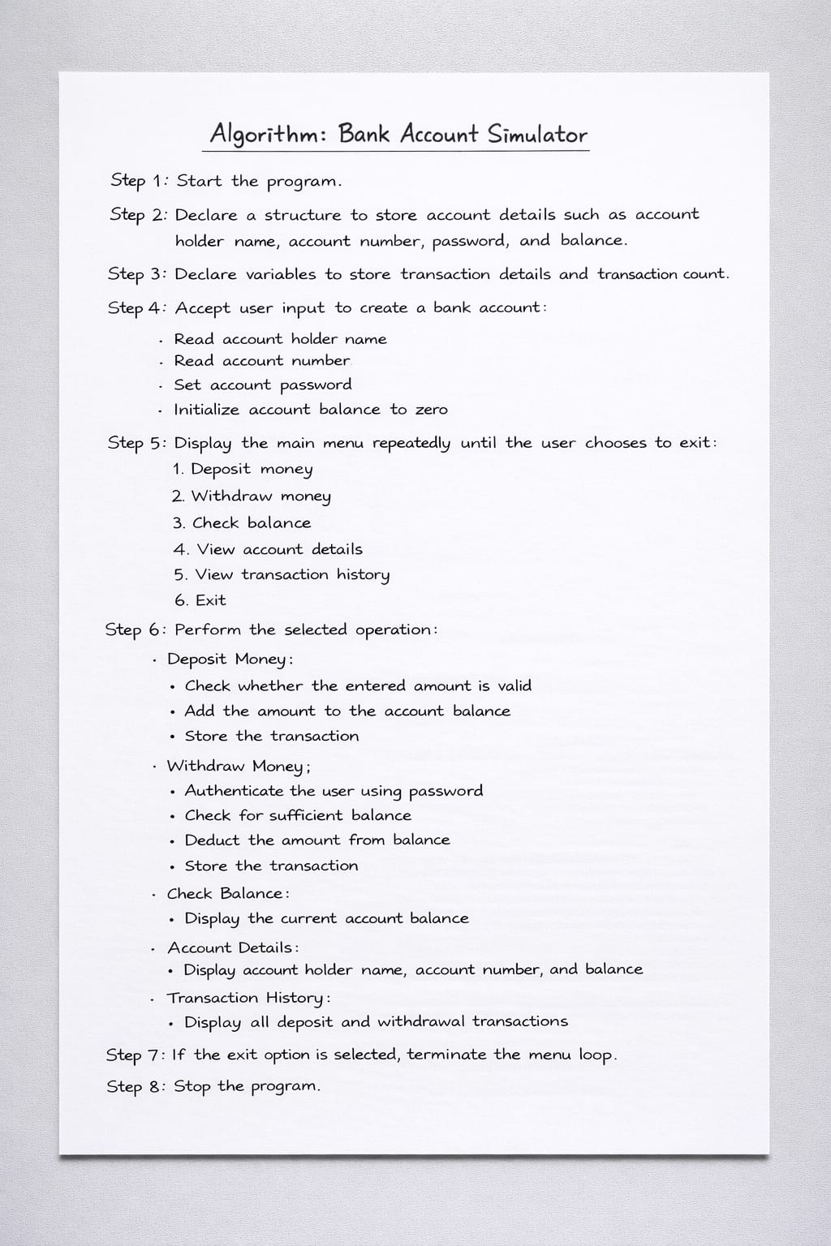

3. FLOWCHART
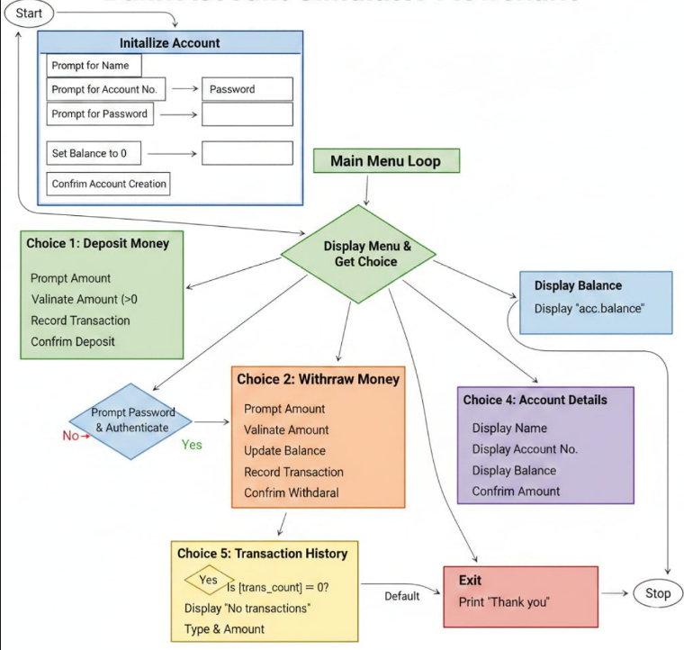

4.Source code
#include <stdio.h>
#include <string.h>

#define MAX_TRANS 100

/* Structure to store bank account details */
struct BankAccount {
char name[30];
int acc_no;
float balance;
char password[10]; // Password is now part of the account
};

/* Global variables */
struct BankAccount acc;
float transactions[MAX_TRANS];
int trans_count = 0;

/* Function to check password against the account password */
int authenticate() {
char input_pass[10];
printf("Enter Password: ");
scanf("%s", input_pass);

if (strcmp(input_pass, acc.password) == 0) {
return 1;
} else {
printf("Access Denied: Incorrect Password!\n");
return 0;
}
}

/* Function to deposit money */
void deposit(float amount) {
if (amount > 0) {
if (trans_count < MAX_TRANS) {
acc.balance += amount;
transactions[trans_count++] = amount;
printf("Amount Deposited: %.2f\n", amount);
} else {
printf("Transaction limit reached!\n");
}
} else {
printf("Invalid deposit amount!\n");
}
}

/* Function to withdraw money with security check */
void withdraw(float amount) {
// Check password BEFORE checking balance or processing
if (!authenticate()) {
return; // Exit function if password is wrong
}

if (amount > 0 && amount <= acc.balance) {
if (trans_count < MAX_TRANS) {
acc.balance -= amount;
transactions[trans_count++] = -amount;
printf("Withdrawal Successful! Amount: %.2f\n", amount);
} else {
printf("Transaction limit reached!\n");
}
} else {
printf("Insufficient balance or invalid amount!\n");
}
}

/* Function to display balance */
void check_balance() {
printf("Current Balance: %.2f\n", acc.balance);
}

/* Function to display account details */
void account_details() {
printf("\n--- Account Details ---\n");
printf("Name : %s\n", acc.name);
printf("Account No : %d\n", acc.acc_no);
printf("Balance : %.2f\n", acc.balance);
}

/* Function to show transaction history */
void transaction_history() {
int i;
if (trans_count == 0) {
printf("\nNo transactions yet.\n");
return;
}

printf("\n--- Transaction History ---\n");
for (i = 0; i < trans_count; i++) {
if (transactions[i] > 0)
printf("Deposit : %.2f\n", transactions[i]);
else
printf("Withdraw : %.2f\n", -transactions[i]);
}
}

int main() {
int choice;
float amount;

/* Initialize account */
printf("--- Create Your Account ---\n");
printf("Enter Account Holder Name: ");
// Clear buffer and use fgets for names with spaces
// scanf(" %[^\n]s", acc.name);
fgets(acc.name,100,stdin);

printf("Enter Account Number: ");
scanf("%d", &acc.acc_no);

printf("Set your Account Password: ");
scanf("%s", acc.password);

acc.balance = 0.0;
printf("\nAccount created successfully!\n");

while (1) {
printf("\n===== BANK ACCOUNT SIMULATOR =====\n");
printf("1. Deposit Money\n");
printf("2. Withdraw Money\n");
printf("3. Check Balance\n");
printf("4. Account Details\n");
printf("5. Transaction History\n");
printf("6. Exit\n");
printf("Enter your choice: ");
scanf("%d", &choice);

switch (choice) {
case 1:
printf("Enter deposit amount: ");
scanf("%f", &amount);
deposit(amount);
break;

case 2:
printf("Enter withdrawal amount: ");
scanf("%f", &amount);
withdraw(amount);
break;

case 3:
check_balance();
break;

case 4:
account_details();
break;

case 5:
transaction_history();
break;

case 6:
printf("Thank you for using the Bank Simulator!\n");
return 0;

default:
printf("Invalid choice! Try again.\n");
}
}
return 0;
}

5 RESULTS

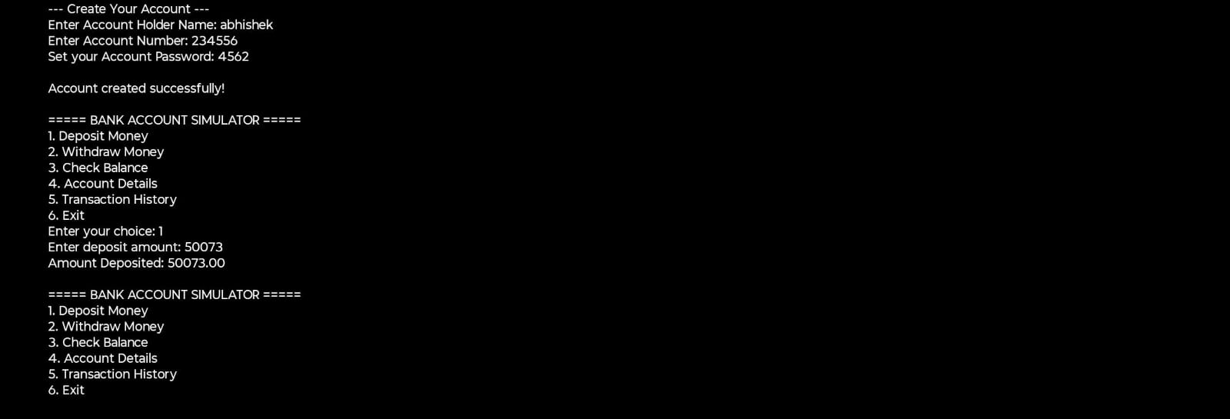
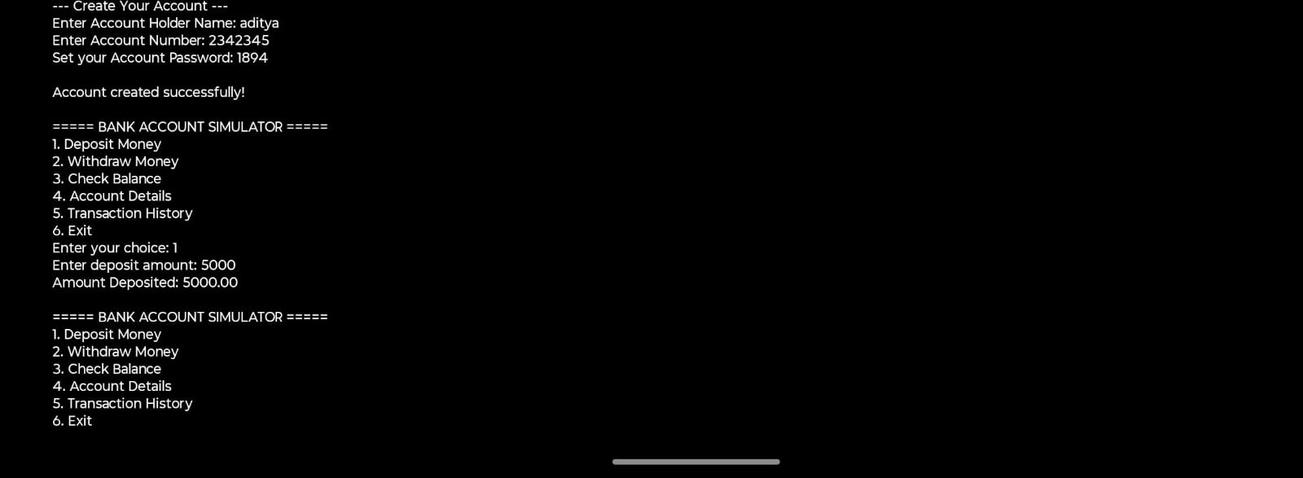

REFERENCES

1. Dennis M. Ritchie, The C Programming Language, 2nd Edition,
Prentice Hall, 1988.
2. E. Balagurusamy, Programming in ANSI C,
McGraw Hill Education, India.
3. Brian W. Kernighan and Dennis M. Ritchie,
C Programming Language, Pearson Education
B.M.S. College of Engineering, Dept. of CSE. AAT Project Guidelines and Report
Format 2024-2025.

